Braintease repository architecture
  - Compilers CPUs runtimes operating systems and applications
Source snapshot 18 October 2026 | Checkout 9215727e plus working tree
Braintease has grown from a Brainfuck development environment into a shared compiler and operating-system ecosystem. RCC IR connects the language frontends to Ripple instructions, native machine code and WebAssembly. The Ripple instruction route can run in RVM or be exported with a CPU implemented in Brainfuck. The native route also enables Fuse-X, which runs a hosted FUZIX kernel and separately compiled applications.
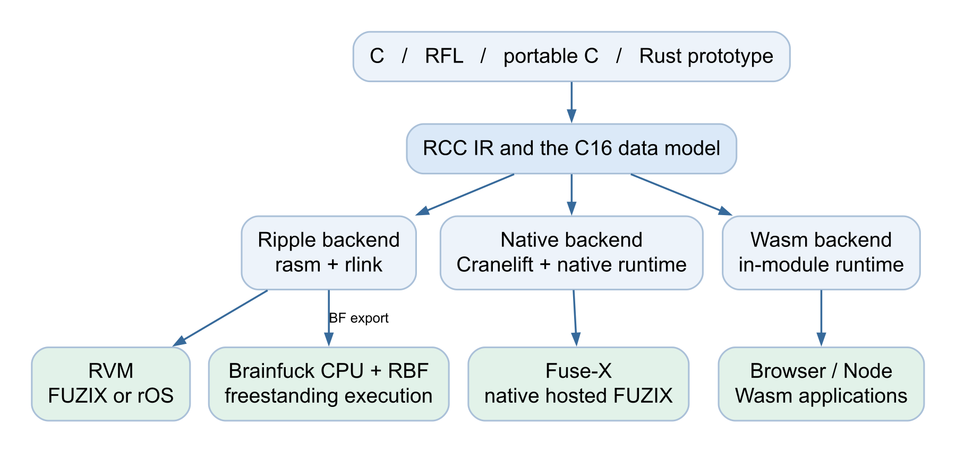
Overview of the compilation and execution routes. The separate repository map expands this into four connected views.

How to read the map
An arrow points from input or provider to consumer. Blue arrows describe compilation and artifacts; green arrows describe execution or services. Dashed purple arrows identify shared implementations. Amber boxes identify experimental or incomplete paths. Repeated component names connect the four views of the larger diagram.
The guide covers the architectural subsystems and groups large collections of utilities and tests by role. It separates implemented paths from prototypes and future work; presence in the checkout does not make every component a supported release. The source trails lead to the current code and local documentation.
Source trail S01 S02 S03 S04 S05

Language frontends and the shared compiler
The frontends answer what a program means. The backends answer how that program executes on a selected target. Their common boundary is rcc-ir, including typed operations, target metadata, storage layout, linking and explicit pointer behavior. Each frontend has its own target coverage; the Rust prototype currently targets Ripple and native output. Shared IR does not mean that a target-specific IR file can be relabeled for another target; the frontend and libraries must be compiled for that target.
Input or component | What it contributes | Current boundary
C through RCC | rcc-preprocessor / rcpp expand C input. rcc-frontend lexes, parses, checks and lowers typed C into RCC IR. | Working C99-oriented compiler; exact coverage is recorded in SUPPORTED_FEATURES.md.
RFL | rfl resolves modules, checks types and ownership, and lowers functions, managed values, closures and async machinery into RCC IR. C imports connect portable engines to RFL interfaces. | Ripple, native and Wasm routes; guest builds add the appropriate Unix SDK.
Portable C | rcc-portable adapts cproc and supplies its own portable preprocessor and direct RCC IR emission. | Installed guest tools; independent full self-hosting and full C11 support remain separate gates.
Rust prototype | rust-rcc uses a pinned real rustc frontend and typed MIR, then legalizes a supported Rust subset to RCC IR. | Experimental no_std-oriented driver and Cargo helper; not general Rust or arbitrary Cargo compatibility.
Shared support | rcc-common supplies common types and diagnostics. rcc-codegen supplies assembly forms, ABI and emission helpers used by the Ripple backend. | Support crates are pieces of the compiler, not additional language frontends.

The data model connects all the targets
C16 uses a 16-bit addressable C cell. C char, short and int occupy one cell; long and logical pointers occupy two; long long and double occupy four. The usual bank size is 64,000 cells, with 32 architectural registers on Ripple. Files and network protocols still use 8-bit octets, so adapters convert explicitly. Native code and generated Wasm preserve the compatibility model rather than adopting the ordinary host C ABI.
RCC and RFL share typed floating-point IR operations. Backend legalization chooses software helpers for Ripple and native floating-point instructions for the native and Wasm routes. This shared layer lets one frontend improvement feed several targets without making every runtime service available everywhere.
Source trail S02 S03 S06 S07 S08 S09 S10 S11

Assembly and the CPU implemented in Brainfuck

The instruction path
The Ripple backend in rcc-backend lowers RCC IR to banked assembly. rasm assembles it into relocatable .pobj objects, and rlink resolves symbols and code placement, accepts .par archives, and emits linked images. Compiler output and hand-written assembly join at this stage. Bank-size settings must agree across the compiler, runtime, assembler and linker.

The Brainfuck path
The same linked instruction program can be exported into a Brainfuck CPU image. The assembler source contains the CPU header and footer templates plus bf_cpu generators for additional microcode. Macro export produces .bfm, which the Rust bfm tool expands into .bf. The linker also has a compact direct .bf export path. The original browser assembly-to-macro service wraps its output in the imported CPU template.
At execution time, the CPU decoder, registers, arithmetic, branches and memory seeking execute as Brainfuck. RBF provides host peripherals at explicit transport boundaries; it does not replace the CPU with a Rust Ripple instruction dispatcher. That distinction is the reason Brainfuck CPU performance depends on the emitted tape algorithms as well as the engine that runs them.

The engines below the CPU
src/rust-bf contains the reusable optimized 16-bit engine, its bf CLI and a browser Wasm library. RBF reuses this engine and offers an optional native BF JIT. The browser also has a TypeScript worker interpreter for interactive stepping and debugging. The CLI and browser engines also run ordinary Brainfuck programs without a Ripple CPU. The general browser interpreters support additional cell-width options; a Ripple CPU image requires the matching 16-bit tape contract.
Host-enabled BF exports carry a layout header and transport annotations for memory reads, writes and instruction boundaries. An ordinary BF interpreter ignores those annotations and cannot provide the associated host devices. Ordinary 16-bit BF export remains a separate route. RBF also supplies capture, replay, telemetry and checkpoint tooling.

Current limits matter
Multiple code and RAM banks, LOADC/STORC and bounded code growth are implemented. Interrupt support is optional at export time and is off by default; the enabled CPU implements IRQ ABI 2, IRET and control-state operations in BF. This does not supply the MMU platform required by the supported FUZIX port. RBF omits PCM and OPL3 audio, and the supported FUZIX launcher explicitly rejects RBF.
Source trail S12 S13 S14 S15 S16 S17

Execution platforms and native processes
Platform | What executes | Role and boundary
RVM | Ripple instructions, through a Rust interpreter or optional instruction JIT. | Reference machine platform with registers, traps, writable instruction memory, MMU and devices. Boots FUZIX/Ripple and rOS.
Brainfuck CPU with RBF | A CPU program and linked application encoded as Brainfuck; optional BF JIT accelerates that BF. | Freestanding experiments and applications with explicit device capabilities. No supported MMU FUZIX route.
Native RCC runtime | Host machine code produced from RCC IR by Cranelift. | Standalone compatibility executables or the execution machinery for native hosted FUZIX. No Ripple fetch/decode loop.
Generated WebAssembly | Wasm instructions and an in-module C16 runtime, hosted by a browser or Node. | Console and browser programs through explicit imports. This is neither a Unix guest nor a general WASI environment.

Two different kinds of JIT
RVM can compile Ripple instructions while running a machine image. RBF can compile Brainfuck operations while running its tape program. RCC native generation instead starts from shared compiler IR. These are different layers, even though they can all result in host instructions.

What makes Fuse X possible
The native backend and rcc-native-runtime preserve logical memory and function tokens while executing native control flow. Resumable C frames retain continuation state across blocking calls, scheduling and fork. They let the hosted FUZIX platform save and select guest process state without treating host fork or a saved host thread stack as the guest process model.
FUZIX owns scheduling, descriptors, process lifetime and system calls in hosted mode. The native runtime supplies the context and loader mechanisms. Private process memory uses copy-on-write, while kernel state is shared. Native FXE packages in the guest filesystem are loaded through explicit runtime helpers, and existing Ripple RXE instruction files are not native executables.
Fuse-X uses software ownership and validation, rather than the RVM hardware-style MMU translation model. Its kernel and long host operations have explicit safe scheduling points and checkpoints; this is not a claim of asynchronous host instruction preemption or a security isolation boundary equivalent to a host operating system.
Source trail S04 S05 S08 S15 S18 S19

Operating systems boot paths and storage
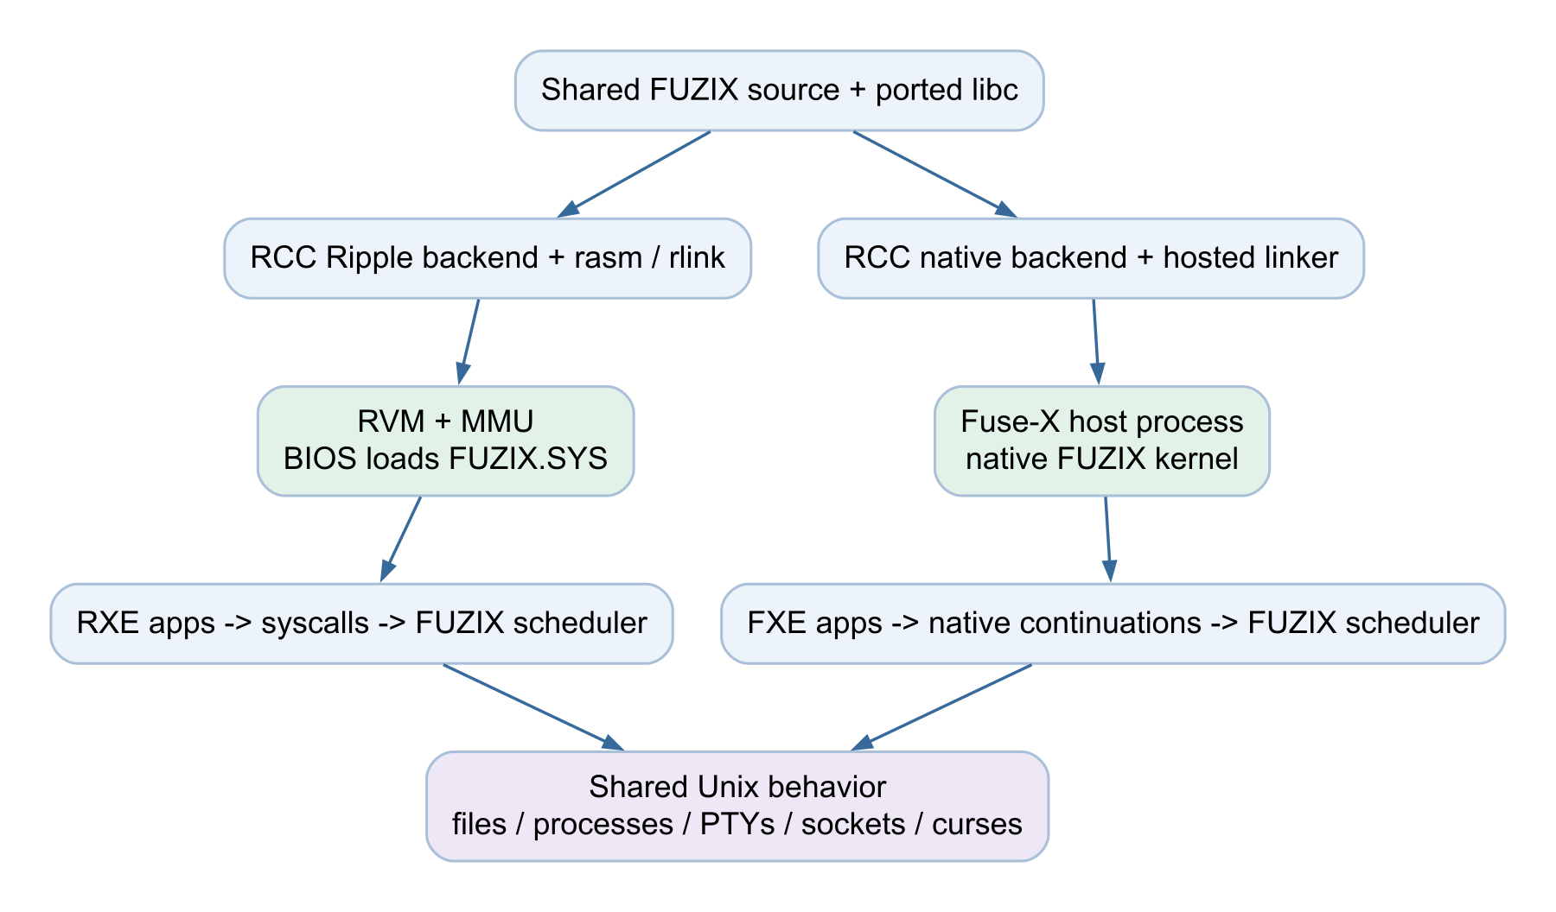
The two Unix platforms share FUZIX sources and behavior but use different execution and package formats.

FUZIX on Ripple
The VM starts a compiled BIOS, loads FUZIX.SYS and enters the Ripple kernel port. Its MMU, trap, context-switching and user-copy code support separately loaded RXE programs. The supported launcher selects RVM with JIT by default and rejects retired non-MMU and RBF configurations.

Native hosted FUZIX
Fuse-X compiles the shared kernel and platform code through RCC native generation. A host process contains the kernel session; independent FXE applications live in its guest filesystem. Init, shells, PTYs, pipelines, job control and the shared Unix application layer remain guest behavior. The macOS integration owns host windows and input while guest execution runs independently.

The separate rOS branch
rOS is a DOS-like system, not a FUZIX layer. Its BIOS loads IO.SYS, then KERNEL.SYS, then COMMAND.COM and RXE applications. IO owns MMIO; the kernel exposes filesystem, exec and INT21-style services. The current launcher boots this branch on RVM.

Storage representations
The Unix ports share C16 V3 filesystem tooling. FUZIX/Ripple places ROOTFS.IMG inside its outer FAT disk; Fuse-X normally uses the raw root image. Ordinary file octets occupy C16 cells inside that root. rOS uses its own FAT16 boot disk. Fuse-X also has a separate shared-folder adapter at /mnt/host that converts ordinary host octets at the boundary. Shared disk format does not make RXE and FXE code interchangeable.
Source trail S04 S05 S16 S20 S21 S22

Devices networking graphics and audio
The machine boundary includes scalar MMIO and versioned DEVICE requests with descriptors in guest memory. The host validates ranges and services explicit operations. RVM device implementations are reused by the native runtime and RBF where supported; sharing implementation code does not imply identical capabilities.
Boundary | Provider and guest layer | What it enables
Console and input | Host TTY, terminal-size queries and bulk output; guest terminal driver, PTYs and curses. | Shells, editors, Commander, mux and terminal applications. RVM now forwards bracketed-paste events to the guest.
Ethernet and sockets | Host Ethernet attachment / NIC queues; guest DHCP, IPv4, UDP, TCP, DNS and socket APIs. | Network tools and applications. The macOS helper attaches Ethernet; it is not a host socket proxy for guest applications.
Entropy and crypto | Host random service and stateless crypto acceleration; guest /dev/crypto and userspace engines. | wolfSSL TLS and Telegram cryptography. Connection state, certificates or MTProto state remain in the guest.
Graphics and images | RGB565 and GX requests, /dev/gfx, Nano-X server/client stack, shared terminal and image libraries. | A whole guest desktop in RVM, native top-level windows in Fuse-X, graphical terminals and NetSurf.
Audio | Shared PCM / OPL3 device services on RVM and the native runtime; Unix /dev/pcm and the C streaming engine. | music / wavplay and standalone audio examples. RBF explicitly lacks PCM and OPL3.
Storage | RVM block device for VM disks; native kernel stream and shared-folder adapters for Fuse-X. | Persistent Unix roots and host-folder access. Native storage MMIO remains unavailable even though Fuse-X has working disks.

Protocol code stays above the device boundary
An HTTPS request travels from a guest browser through guest TLS and sockets, the guest TCP/IP stack and the Ethernet device to the host attachment. Telegram instead uses its own guest MTProto transport and authentication engine; it does not use TDLib or a host Telegram helper. Crypto acceleration supplies operations, not a replacement protocol client.
PCM samples are copied through bounded queues to the host output sink. The guest music engine performs WAV parsing, conversion, buffering and device control. OPL3 support in the underlying device layer does not imply Ogg or MP3 decoding in the music player.
Source trail S23 S24 S25 S26 S27 S28

Terminal applications and shared libraries

RFL interfaces with C engines
Commander, Rift, Telegram and music are RFL terminal applications over the shared guest libc and curses. Their C engines handle work that benefits from tight loops or portable library implementations. The same source family builds RXE programs for FUZIX/Ripple and FXE programs for native Fuse-X.
Application | Dependencies and behavior | Current scope
Commander | std/posix and std/curses; shared dialogs, files, themes, Unicode and text engine. | Two panels, file operations, guest shell, editor launch and text preview with word wrap or horizontal scrolling.
Rift | C gap buffer, indexed lines, undo, Unicode and syntax cells; RFL vi commands, UI and settings. | Editing, tabs, search, guest runners, visual wrap, configurable typed-text formatting and saved settings.
Telegram | C MTProto / TL / authentication / account engine, guest TCP and crypto, QR library, RFL curses UI. | QR login, two-factor password, saved sessions, searchable/pinned chat list, history and incoming/sent text. Prototype with text and terminal limits.
music and wavplay | RFL file browser plus C WAV streaming and conversion, /dev/pcm. | 8/16/24-bit PCM WAV, mono/stereo. Ogg and MP3 remain investigation rather than implemented playback.
Lynx and network tools | Shared curses, guest sockets/DNS and guest TLS where needed. | Text web browsing and command-line networking; protocols run in guest software.
Shell and interpreters | Ported Bourne sh, awk, Tcl/Picol, BASIC and bf; ordinary guest file and terminal APIs. | Scripts, pipelines, jobs and language programs. The guest bf interpreter is distinct from the RBF host on the development machine.

Libraries form reusable connections
The optional C libraries under libraries/ supply the text buffer, UTF-8/graphemes and terminal widths, INI parsing, semantic themes, QR encoding and image decoding. RFL bindings under rfl/lib expose those capabilities. Core curses supplies cells, windows and terminal modes; application libraries and applications decide file paths, roles, settings and higher-level behavior.
Source trail S29 S30 S31 S32 S33 S34

Graphical applications and current port boundaries

One drawing stack with two window models
GX is the shared graphics boundary. FUZIX/Ripple uses its MMU-aware /dev/gfx path and Nano-X server to compose windows into one guest display. NanoWM manages the guest windows, and NXDSKTOP supplies the current upstream desktop. Fuse-X uses the hosted graphics adapter and native macOS top-level windows; macOS supplies window management rather than a guest NanoWM desktop.
The shared terminal renderer feeds gterm and nxterm. PTYs connect those terminals to independent shells and full-screen applications, so GUI terminals, physical-console sessions and Telnet reuse the Unix terminal/process layer. Nano-X companion applications include selectors, dialogs, calculator, clocks, eyes and Tetris. Availability varies by target and installed inventory.

FuseDE is a foundation and a direction
The implemented FuseDE foundation includes skins, icon resources, nine-slice drawing, a showcase application and shared workspace/window inspection services. NanoWM already uses parts of that foundation. A custom desktop shell, general widget toolkit and portable dock remain later milestones; the current upstream desktop should not be relabeled as a completed FuseDE environment.

The graphical browser
The NetSurf port builds the real browser core and a Nano-X frontend for both Unix platforms. It supplies bounded HTML/CSS rendering, HTTP/HTTPS, links, editable fields, history, scrolling/resizing and selected image formats. JavaScript, uploads/POST, downloads and multiple browser windows/tabs are not enabled in this port.

QuickJS and audio formats remain separate work
QuickJS is a porting experiment. Its full engine runs in a host reference harness, while adapted value representation, utilities and number conversion run in guest probes. Those probes do not establish guest JavaScript evaluation, and no qjs or replacement NetSurf JavaScript adapter is installed by that experiment. Likewise, codec feasibility work for Ogg or MP3 does not add those formats to music.

Doom belongs on the freestanding branch
The Doom port and graphics demos exercise the compiler, runtime and device interfaces directly. RVM and native builds exist, and a BF launcher is experimental. This path is useful architectural evidence for several execution backends; it is not proof that every game runs as an ordinary Unix desktop application or that every backend has the same audio capabilities.
Source trail S24 S25 S33 S35 S36 S37 S38

Guest compilers browser tools and earlier branches

The portable toolchain moves compilation into the guests
rcc-portable supplies a portable C preprocessor and cproc-derived frontend, a baseline Ripple backend, assembler, streaming linker and cc driver. The guest pipeline is rcc-c to rcc-ripple to rcc-as to rcc-ld. Headers, startup and libraries live under /usr/lib/rcc. It runs inside both Unix environments and currently emits Ripple RXE programs.
Inside Fuse-X, that output is a cross-compiled Ripple program, not a native Fuse-X executable. Native FXE generation still depends on the host compiler/backend and packaging. The current self-hosting milestone rebuilds one Ripple compiler generation from raw C inside Fuse-X and runs the resulting RXE tools under FUZIX/RVM. Comparing subsequent generations and independently rebuilding the initial SDK remain acceptance gates.

The Rust frontend is a different experiment
rust-rcc uses rustc-private typed MIR and an explicitly pinned compiler toolchain. It maps Rust octets into C16 cells, supplies rustcell support and reuses the existing Ripple/native backends and Unix SDKs. Its Cargo helper handles a tested no_std-oriented subset, host build scripts and host procedural macros. It is not a general rustc codegen backend or a complete Rust standard library port.

The original development environment remains useful
The browser IDE uses React, TypeScript, Vite and RxJS for Brainfuck, macro and assembly editing, source maps, tape visualization and debugging. TypeScript workers provide macro and interpreter paths; Rust macro, assembler and BF implementations also have Wasm builds. Electron packages the development UI. RFL also has an LSP and IntelliJ integration; Brainfuck syntax packages include VS Code and TextMate support. These are host development surfaces, distinct from applications running inside FUZIX or Fuse-X.
The older rbt CLI orchestrates rasm, rlink, bfm and optionally the bf interpreter. It is a build wrapper, not the Rust-language frontend. The newer rcc, rfl, rct and launch/build scripts orchestrate their own relevant portions of the pipeline.

Two meanings of Wasm
A Wasm build of the BF interpreter executes Brainfuck in the browser IDE. In contrast, rcc-wasm compiles RCC IR directly into a Wasm program. That newer route has its own in-module runtime and explicit browser bridge; RFL typed UI and owned async effects use batched DOM, events, timers and fetch. It does not boot a FUZIX kernel or expose the Unix guest SDK as WASI.
docs/archive, src/experiments, src/rnd and the early ports/fuzix/native process proof preserve older designs and evidence. The process proof is not the current Fuse-X implementation, and draft language documents do not by themselves establish implemented features.
Source trail S01 S07 S09 S10 S12 S14 S17 S39 S40

Build entry points validation and application inventory
Area | Main entry points | What they connect
C and standalone tests | rcc, rcpp, rct / rcc-test; c-test; runtime/Makefile | C preprocessing and compilation, runtime linkage, VM/native/BF runs and expected-output checks.
Assembly and BF | rasm, rlink, bfm, bf, rbf; scripts/build-bf.sh; rbt | Objects and archives, CPU export, macro expansion, BF execution and device host experiments.
RFL | rfl check / compile / run / build; rfl/tools/build_os.py; LSP and editor integration | Language checking and target-specific code generation; C bridges and the selected Unix SDK for guest packages.
Unix systems | scripts/run-fuzix.sh; scripts/run-fuse-x.sh; scripts/build-os.py; Makefiles | Compilers, kernels, SDKs, managed applications, incremental builds, image upgrade/install and launch.
rOS | scripts/run-ros.sh; c-test/examples/rOS | Separate BIOS, system images, shell, runtime and FAT disk.
Port validation | ports/*/tests and tools; rfl/tools; rvm/tests; Rust crate tests | Private-disk integration, terminal/pixel/network probes, persistence, correctness and performance evidence.

The installed Unix family is larger than the named ports
The FUZIX application manifest includes file and text tools such as cat, ls, cp, mv, ln, find, grep, sed, sort, uniq, head, tail, wc, cut, tr, diff, diff3, tar, dd, od, cksum, sum, split, join, column, fmt and pr. Directory, identity and process tools include mkdir, rmdir, rm, touch, chmod, chown, chgrp, df, du, id, whoami, groups, ps, top, free, uptime, kill, nice, nohup, time and sleep.
The terminal and development group includes sh, stty, tty, clear, more, less, man, ed, Levee, vile, Rift, Commander, mux, make, m4, dc, expr, awk, Tcl/Picol, BASIC and bf. Networking adds ifconfig, ping, echoping, dig/host/nslookup, htget, ntpdate, Telnet, Lynx, NetSurf and Telegram. Games/demos include Sokoban, Wumpus, Hamurabi, Tetris, graphical companions and the separate Doom port. Generated inventories and build results determine target availability; this list is a family map, not an assertion that every upstream FUZIX program has been ported.

Where to verify an architectural claim
Use the relevant current implementation and its acceptance tests before an old overview or roadmap. Package manifests identify shared crates; launchers identify supported boot targets; executable loaders identify formats; device code and capability tests identify real services. Port READMEs describe bounded application scope. This guide records those relationships and does not imply that all listed suites were rerun for this document.
Source trail S01 S02 S16 S17 S29 S35 S39 S41

Source index
Paths are relative to the repository root. Source trails in the guide refer to these identifiers. Implementation files take precedence over outdated summaries; roadmaps and prototypes are identified explicitly.
S01 Workspace and development UI
Cargo.toml; package.json
S02 Current machine and C model
docs/arch/overview.md; docs/arch/registers.md; docs/arch/abi.md
S03 Shared IR and target records
rcc-ir/src/lib.rs; rcc-ir/src/target.rs; rcc-ir/src/link.rs
S04 Native compilation and compatibility ABI
rcc-native/README.md; rcc-native/Cargo.toml
S05 Current hosted architecture
docs/fuse-x/architecture.md; fuse-x/README.md
S06 C frontend and driver
rcc-frontend/src/lib.rs; rcc-driver/src/main.rs; SUPPORTED_FEATURES.md
S07 RFL compiler and managed calls
rfl/src/lib.rs; rfl/src/main.rs; rfl/lowering.md
S08 Backend support and native processes
rcc-backend/src/lib.rs; rcc-codegen/src/lib.rs; rcc-native/PROCESSES.md
S09 Portable C toolchain
rcc-portable/README.md; docs/self-hosting/README.md
S10 Rust frontend prototype
rust-rcc/README.md; rust-rcc/compile.py; rust-rcc/cargo.py
S11 Direct IR to WebAssembly
rcc-wasm/README.md; docs/rfl/browser-ui.md
S12 Assembler linker and CPU export
src/ripple-asm/src/linker_main.rs; src/ripple-asm/src/macro_formatter.rs
S13 BF CPU templates and generators
src/ripple-asm/src/cpu_header.bfm; src/ripple-asm/src/cpu_footer.bfm; src/ripple-asm/src/bf_cpu/mod.rs
S14 BF engines
src/rust-bf/README_ENGINE.md; src/rust-bf/src/lib.rs; src/services/interpreter/interpreter.worker.ts
Repository root /Users/ahineya/projects/braintease

Source index continued
Paths are relative to the repository root. Source trails in the guide refer to these identifiers. Implementation files take precedence over outdated summaries; roadmaps and prototypes are identified explicitly.
S15 Brainfuck host and device limits
rbf/README.md; rbf/Cargo.toml; src/ripple-asm/BF_HOST.md
S16 Supported Unix VM launch path
scripts/run-fuzix.sh; ports/fuzix/README.md
S17 BF build wrappers
scripts/build-bf.sh; rbt/src/main.rs; TOOLCHAIN.md
S18 Reference virtual machine
rvm/README.md; rvm/src/vm/execution.rs; docs/arch/mmu.md
S19 Native packages and loader
fuse-x/EXECUTABLES.md; fuse-x/exec.c
S20 rOS layers and boot formats
docs/arch/ros.md; scripts/run-ros.sh
S21 Shared Unix disk layout
docs/arch/c16-filesystem.md; ports/fuzix/tools/disk.mjs
S22 Native root and host folder adapters
docs/fuse-x/storage.md; fuse-x/hostfs.c
S23 Machine services and crypto
docs/arch/mmio.md; docs/arch/crypto.md; runtime/include/vm_devices.h
S24 Graphics architecture
docs/graphics/README.md; docs/graphics/architecture.md
S25 Audio services
docs/arch/audio.md; runtime/include/vm_audio.h
S26 Guest network stack
docs/networking/README.md; ports/fuzix/ripple/sockets.c
S27 Guest TLS
ports/tls/README.md
S28 Native runtime service reuse
rcc-native-runtime/Cargo.toml; rcc-native-runtime/src/lib.rs
Repository root /Users/ahineya/projects/braintease

Source index continued
Paths are relative to the repository root. Source trails in the guide refer to these identifiers. Implementation files take precedence over outdated summaries; roadmaps and prototypes are identified explicitly.
S29 Guest APIs and Commander
rfl/os/README.md; rfl/apps/commander/widgets.rfl; docs/terminal-multiplexer.md
S30 Rift text editor
rfl/apps/rift/README.md; libraries/text/text.h
S31 Telegram guest engine and UI
ports/telegram/README.md; rfl/apps/telegram/main.rfl
S32 WAV music player
ports/music/README.md; rfl/apps/music/main.rfl
S33 Shared application libraries
libraries/README.md; libraries/unicode/README.md; rfl/lib/README.md
S34 Languages and terminal browser
ports/basic/README.md; ports/lynx/README.md; ports/fuzix/README.md
S35 Nano X and current desktop
ports/nanox/README.md; ports/nanox/desktop.mk
S36 FuseDE foundations and remaining work
ports/fusede/README.md; docs/fusede/implementation-plan.md
S37 Graphical browser and JS experiment
ports/netsurf/README.md; ports/quickjs/README.md
S38 Doom and its backend paths
ports/doom/README.md; ports/doom/run.sh; rbf/README.md
S39 IDE assembly macro and editor tooling
src/services/assembly-to-macro.service.ts; src/cpu/template.ts; src/bf-macro-expander/README.md; rfl/editors/intellij/README.md
S40 Earlier designs and native process proof
docs/archive/README.md; ports/fuzix/native/README.md
S41 Build and application inventories
scripts/build-os.py; fuse-x/Makefile; ports/fuzix/Makefile; rcc-test/Cargo.toml
Repository root /Users/ahineya/projects/braintease

